KS3 WIDER COMMUNICATION

ACTIVITY 5

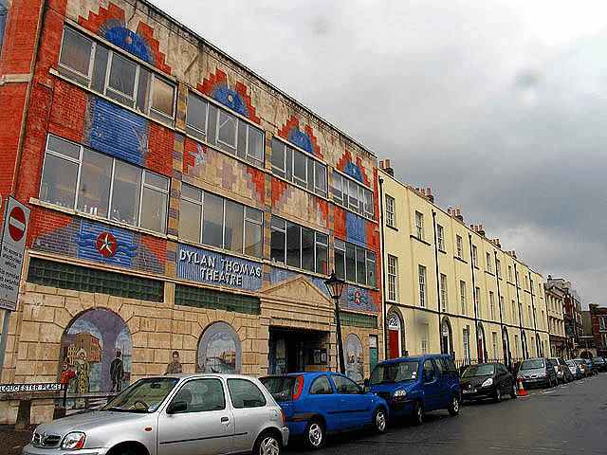

This is a photograph of Swansea’s Dylan Thomas Theatre today. In Dylan’s time, the Little Theatre was in Mumbles.

The Little Theatre had a great influence on Dylan’s life. He learnt how to perform in front of an audience, something which would stand him in good stead later when broadcasting on radio and reading his work in public.

- Choose one or more places which you think are influential in your life, and explain to the rest of the class why this is so.

